Student Name _________________________ October 25th, 2015

Weekly Second Grade Homework:
Homework Tic-Tac-Toe!
Complete 3 or more activities in a straight line or diagonal to get a homework tic-tac-toe! Place an X in the box when you complete the activity. Attach your work.
Due: Friday October 30th, 2015
How can your body parts be used as tools? Explain and draw a picture of how you could use your body as a tool. | Tell about the different places in your community. Where do you shop?  Where do you live?  Where do people work?  Where do people play? | Draw a bar diagram to model and solve the problem:  There are 3 plates. There are 5 oranges on each plate.  How many oranges are there in all?
Write your spelling words as big as you can, in medium size, and as small as you can. | Draw an array and use repeated addition to solve the problem:  Terry puts apples in 4 columns, with 4 apples in each column. How many apples does Terry have? | Explain the steps you might take when inventing something. What do you do first, second, third, and last?
What is transportation? List as many different forms of transportation as you can, including transportation in air, water, and land. | Write a story about a creature from another planet, who finds a magic wand, at an old spooky house.  Underline the character, and circle the setting. | Dribble and shoot your spelling words. Dribble out each letter and shoot the word.

Spelling Words (long i, silent e): fine, wipe, swipe, ride, ripe, bike, wide, life, while, file, time, hide, dime, side, mine

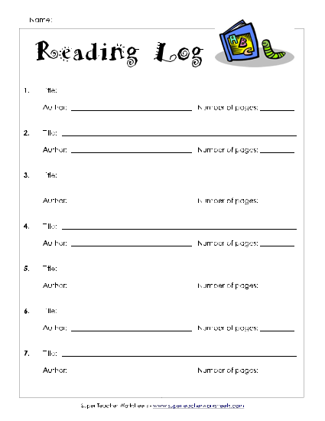

Remember to read every night for at least 20 minutes!
Reading Log must be filled in and signed nightly!
Parent Signature ______________________________________

